**9-21-23 notes**

Scripting Practice in VBA

Skills from this lesson:

* Format spreadsheets with VBA code.
* Loop through a table with VBA code and check for changes in values.

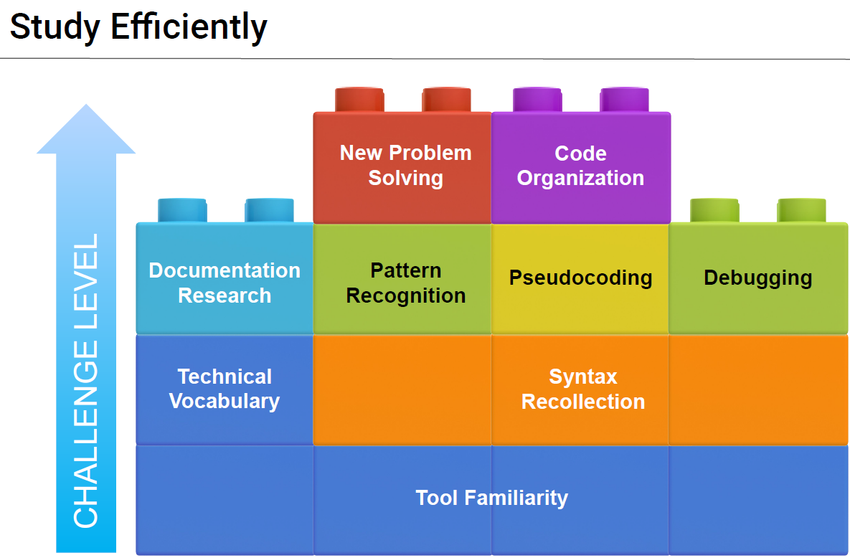

Psuedocoding- Planning what you’re going to code

* Example: Make an array, shove whichever column of data in, manipulate the data this way

**GitHub:**

Example folder setup for smooth class work flow

Step 1 : On Windows, open a GitBash window, on Mac, open a Terminal Window

Step 2 : Navigate to your "Home" folder with following command : cd ~

Step 3 : Create a folder for your classwork and homework : mkdir DataClass

Step 4 : Navigate to your class folder : cd ~/DataClass

Step 5 : Clone the class GitLab repository : git@uci.bootcampcontent.com:UCI-Coding-Bootcamp/Michigan-State-University/MSU-VIRT-DATA-PT-09-2023-U-LOLC

Step 6 : Navigate in to the class repo : cd UCI-VIRT-DATA-PT-03-2023-U-LOLC

Step 7 : "Pull" the latest from the class repo : git pull

Step 8 : Using the Windows File Explorer or Mac Finder, add your DataClass folder and your UCI-VIRT-DATA-PT-03-2023-U-LOLC folder to your Quick Access list or Favorites list respectively.

** If any issues or questions, we can address during office hours.

VBA syntax is (Row, column)

Excel is (Column, Row) IE: A1

**StarCounter official solution**

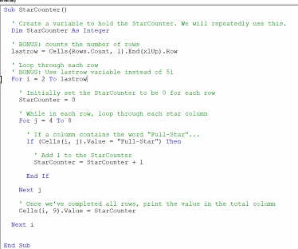

**Formatter solution:**

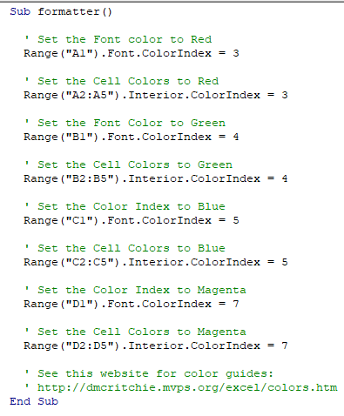

**Gradebook Solution:**

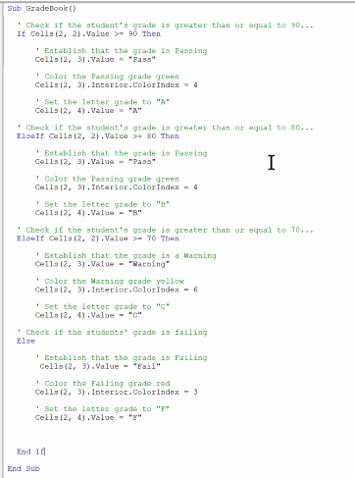

**Checkerboard Solution:**

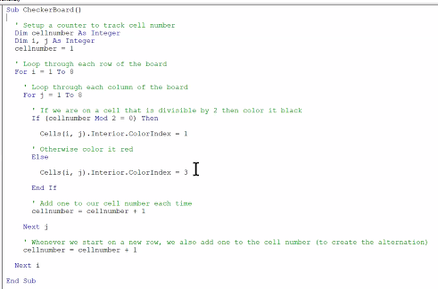

^from professor resources

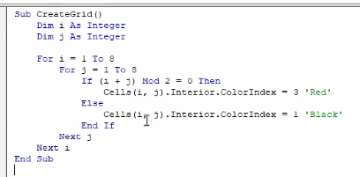

^From the internet.

The magic is in: If (i+j) mod 2 = 0 then

'Mod works off of values within cell

'Bill Smith had an idea to base the mod off of i=j

'if (i+j) mod 2 = even then [cell is black]

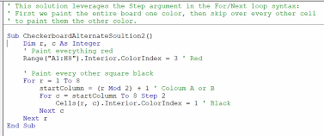

^alternate (more difficult) solution

Sub CreateGrid()

Dim i As Integer

Dim j As Integer For i = 1 To 8

For j = 1 To 8

If (i + j) Mod 2 = 0 Then

Cells(i, j).Interior.ColorIndex = 3 'Red'

Else

Cells(i, j).Interior.ColorIndex = 1 'Black'

End If

Next j

Next i

End Sub

^Michael’s solution as text

**Next Cells Solution:**

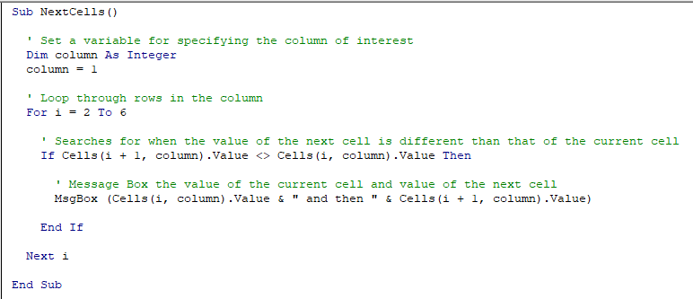

**Credit Card checker:**

Can pivot to get info, or CODE!!!

Make button to run script

Pseudocoding:

Make array

Pull lines where the column A is unique

Sum column C (Amount charged) for each unique value

Spit out a summary with the unique column A and sum of

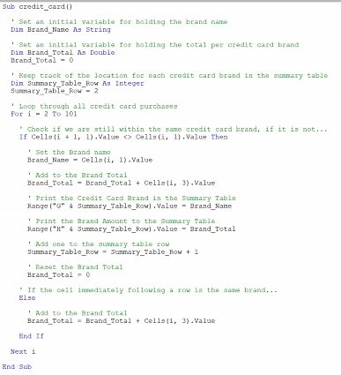

**^THIS WILL BE VERY HELPFUL FOR VBA CHALLENGE HOMEWORK**

If cells line is the heart of the logic

<> means not equal

Else Brand_total…. value

Adds the amount to the brand total

This code works if column A is grouped together by type. If it’s not grouped together, it needs data wrangling (in order to be sorted) before you work with it

**Census Data project**

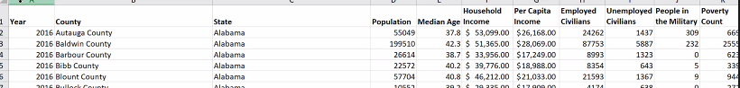

Split county and state and put state in new column

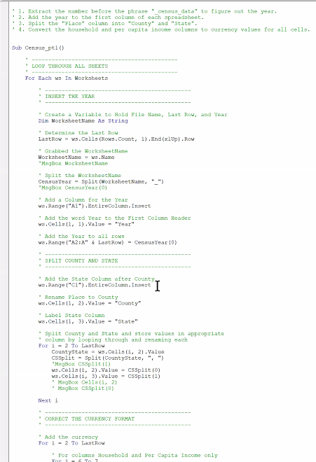

^ Official solution

Just below the line that says-

‘Add the year to all rows

Range(“a2:a”) says the whole column A except row 1

If you Determine Lastrow (just below Dim statement in inserting the year)

For I = 2 to Lastrow

^Makes it so you can just use the last row instead of a specific number

